Git Challenges

- Resolve Merge Conflicts
  - Create a merge conflict intentionally (two users editing the same line).
  - Resolve the conflict and push the changes.

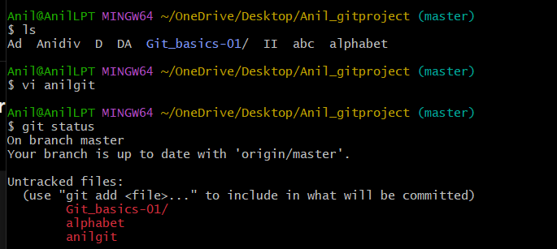
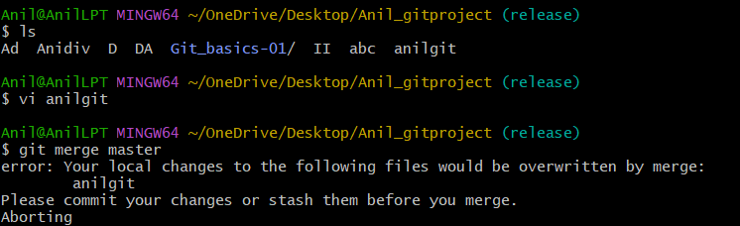
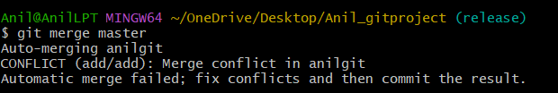
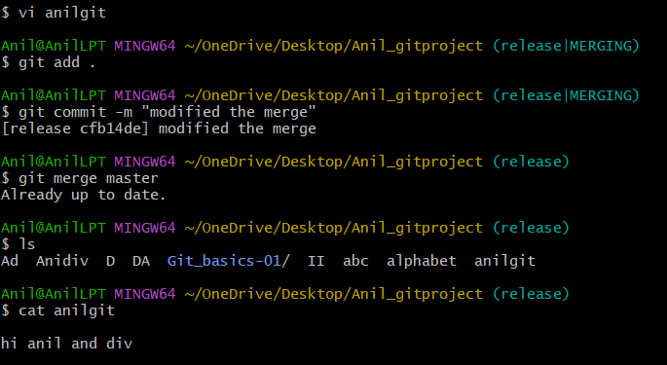

- Recover Deleted Branch
  - Delete a local branch and then recover it using the reflog.

Check current branch
Create a new branch
Create a file in that branch
Add the file to Git
Commit the file
Switch back to master
Delete the local branch
Check branche
Open reflog
Recover the deleted branch
Verify branch is recovered

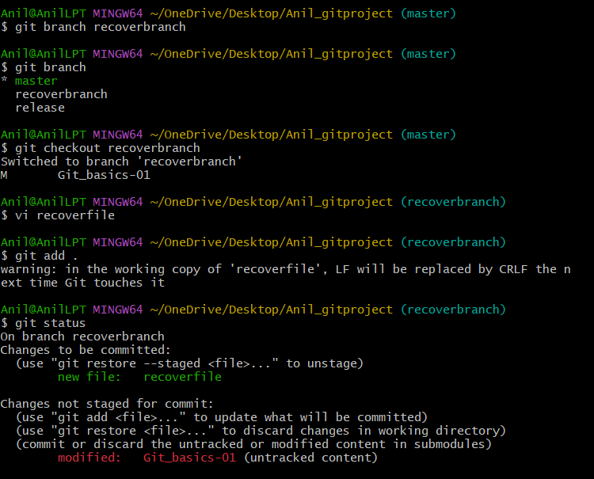
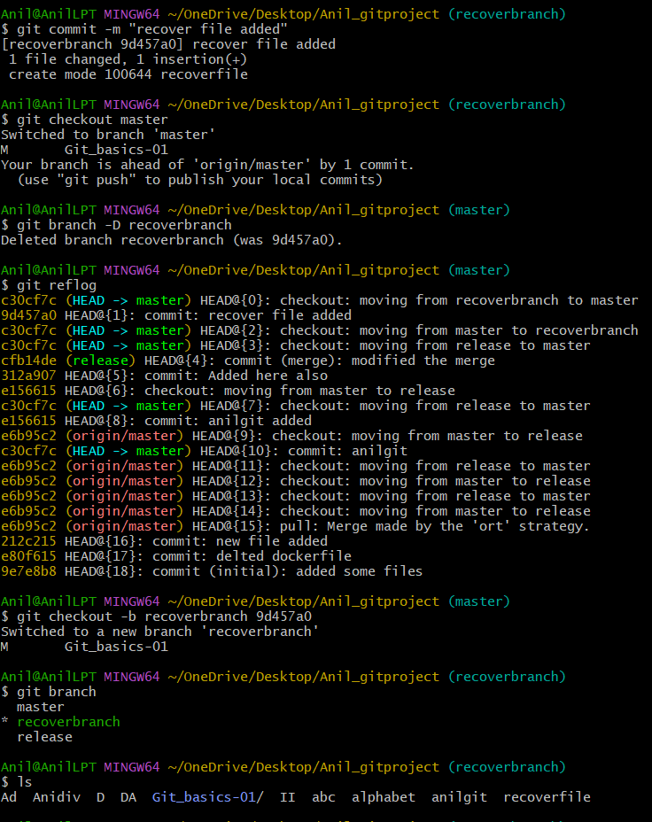

- Undo Wrong Push
Push a wrong commit to GitHub, then undo it without losing history
Main command - git revert

Check current branch
Make sure you are on the branch where you want to do the task
Pull latest changes from GitHub
Create a file intentionally
Add the wrong file
Commit the wrong change
Push wrong commit to GitHub
Check commit history
Undo the wrong commit without losing history
(Use git revert)
Push the revert commit to GitHub
GitHub will have both commits:
wrong commit
revert commit
Verify history -This means the wrong commit still exists in history, but its changes are undone.
Check file is removed (ls)
This does not delete Git history. Instead, it creates a new commit that reverses the wrong commit.
This is the correct method when the wrong commit is already pushed to GitHub.
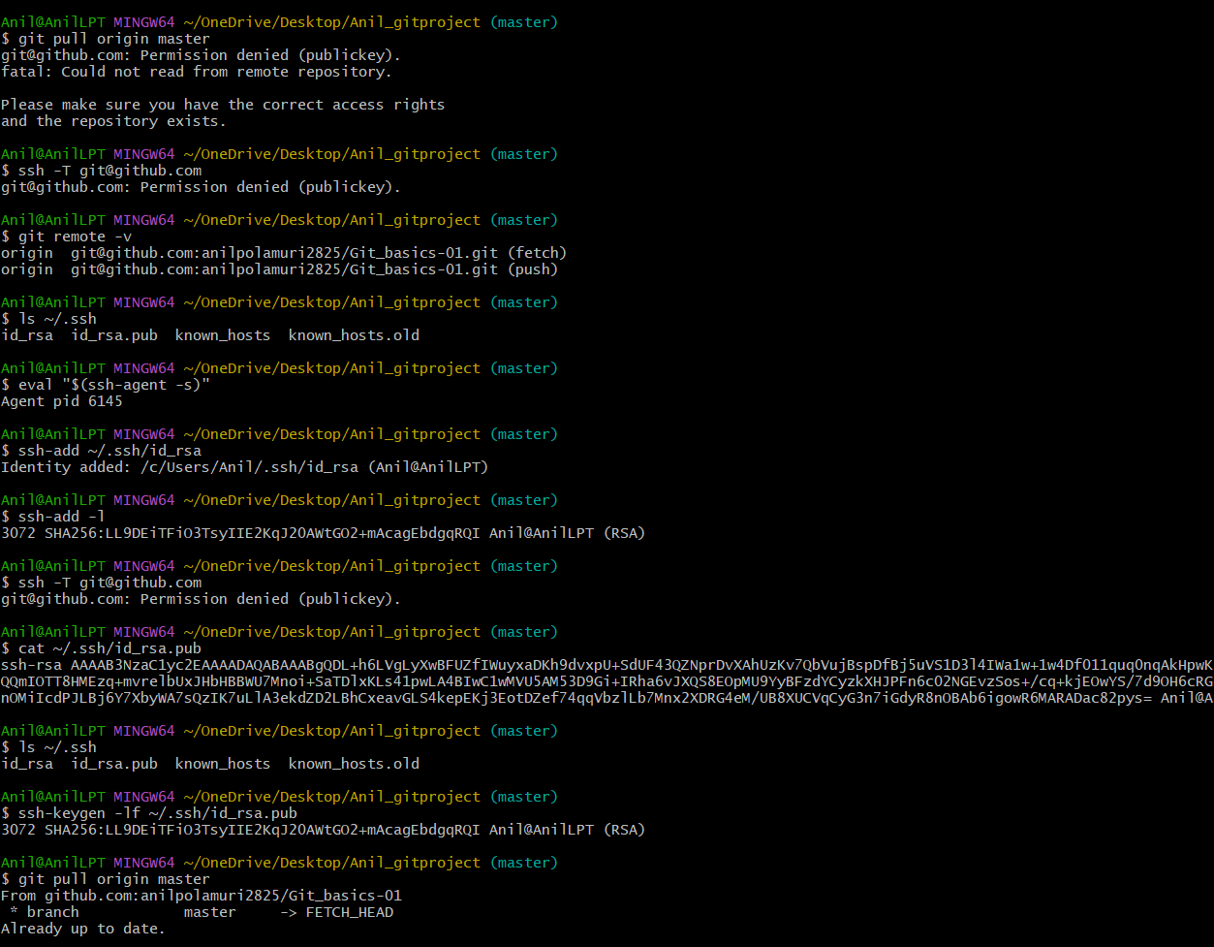

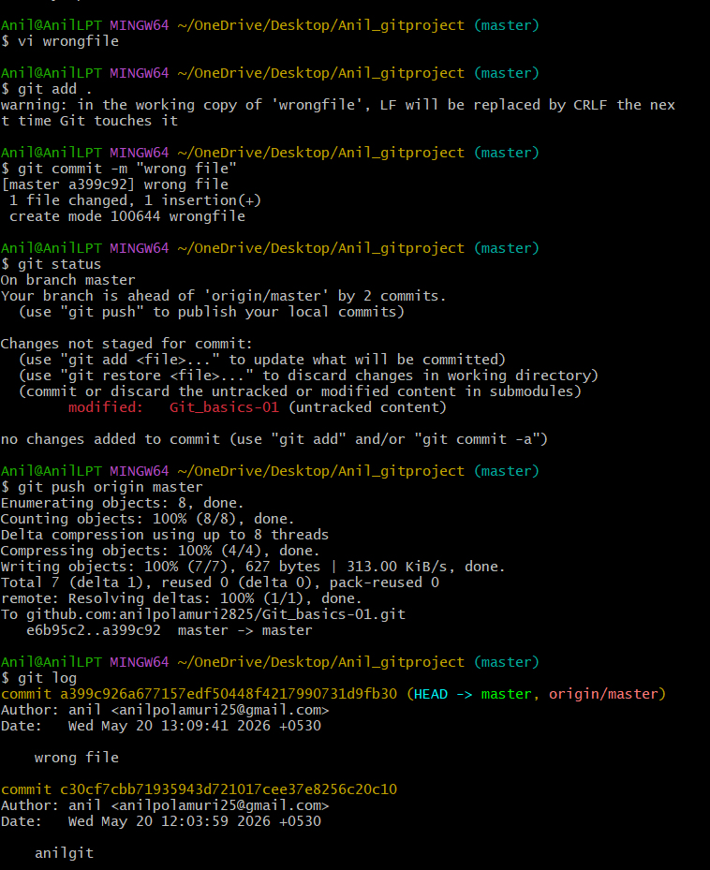
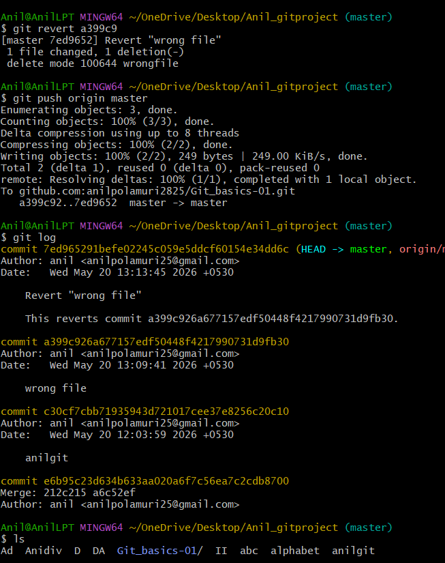

- Amend a Commit
  - Make a commit, then add a missing file to it usinggit commit --amend.
  - Make a commit, then realize one file was missed. Add the missing file into the same previous commit using
  - git commit --amend is used to modify the most recent commit.
Check your current branch
Switch to master branch
Create first file
Add content in file1, save and exit
Add and commit file1
Create the missing file
Add content in file2, save and exit
Add missing file and amend previous commit
Check log
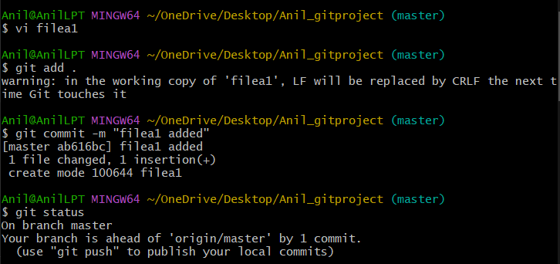
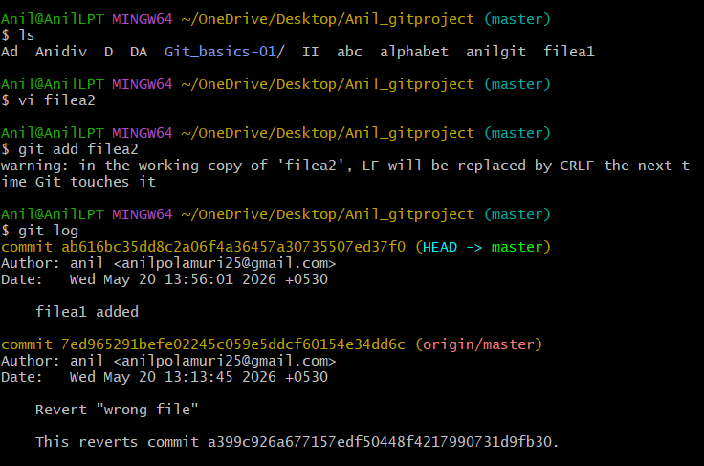
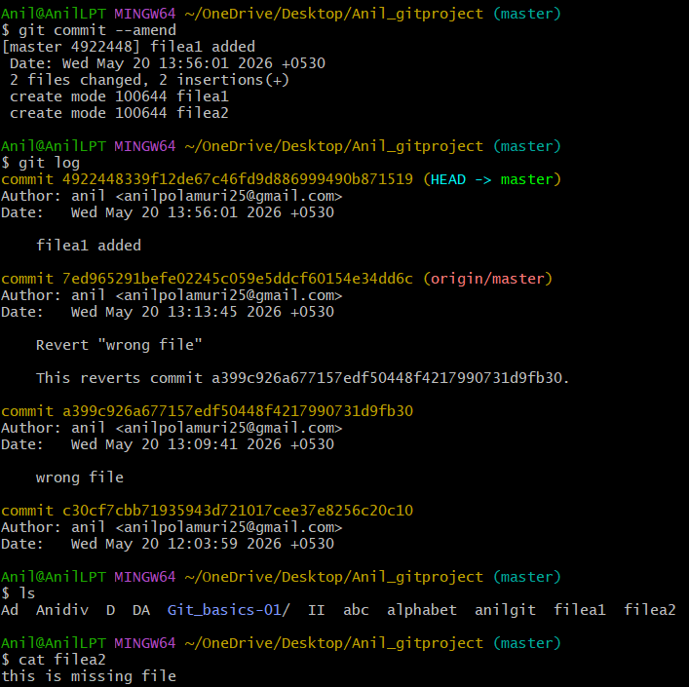

- Cherry-pick a Commit
  - Take a specific commit from one branch and apply it to another branch.
  - is used when you want to copy one specific commit from one branch to another branch
  - Switch to the branch where you want to create the commit
  - Create a new file
  - Add content inside the file
  - Save and exit
  - Add and commit the file
  - Copy the commit ID
  - Switch to the branch where you want to apply that commit
  - Cherry-pick the commit
  - Verify the file

  - 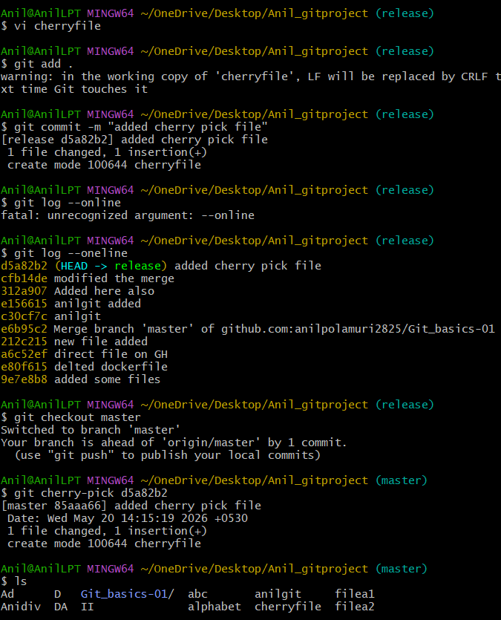

- Interactive Rebase
  - Reorder and squash multiple commits into a single clean commit.
  - squash means combine one commit with the commit above it.
  - Create 3 files
  - Add and commit
  - Check last commits (git log --oneline)
  - Start interactive rebase for last 3 commits(git rebase -i HEAD~3)
  - Squash commits by keeping first commit as pick and changing others to squash
  - Save and exit
  - Git will open another editor for commit message.
  - Replace the messages with one clean message
  - Save and exit again

  - 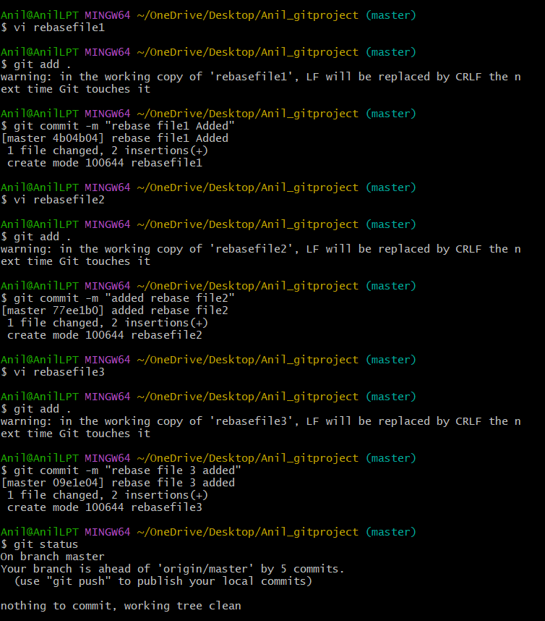
  - 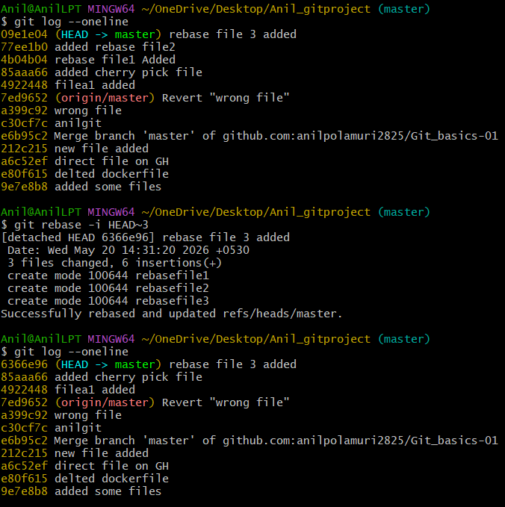

- Tagging & Release
  - Create a version tag (v1.0), push it to GitHub, then delete and restore it.
  - A tag is used to mark a specific commit as a release version
  - Git tag is like a label/name given to a specific commit
  - Go to master branch
  - Pull latest code
  - Check commits
  - Create tag (This tag is only local now. It is not yet on GitHub.)
  - Check local tags (git tag) - This confirms the tag was created locally
  - Push tag to GitHub - git push origin v1.0
  - Now GitHub also has the release tag v1.0.
  - Delete tag locally - git tag -d v1.0
  - Delete tag from GitHub - git push origin --delete v1.0
  - To restore the tag, create it again and push it again
  - Restore tag locally-This creates the tag again on the current latest commit
  - Push restored tag to GitHub-This uploads the restored tag to GitHub again

  - 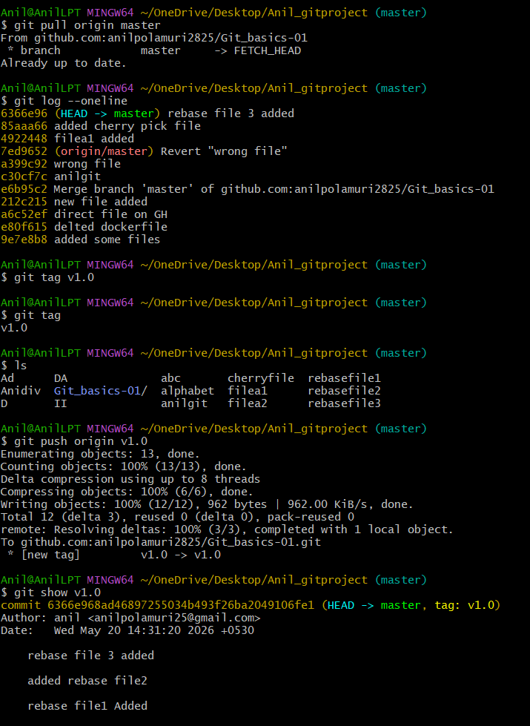
  - 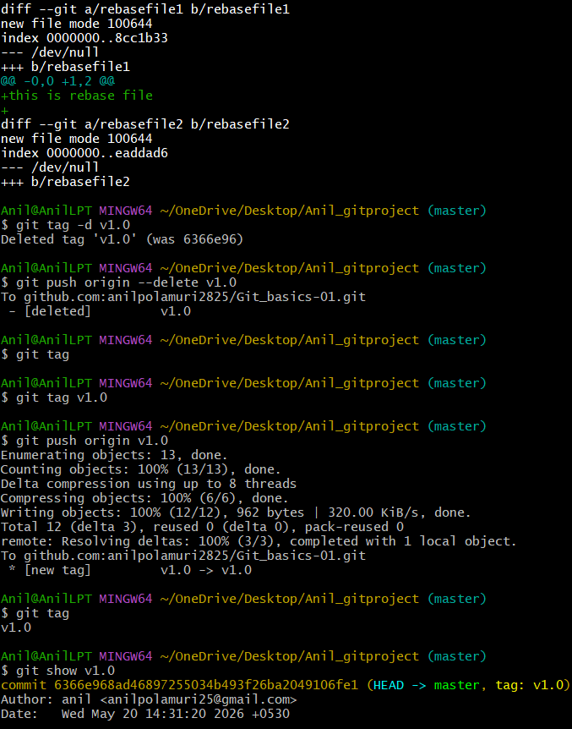
  - 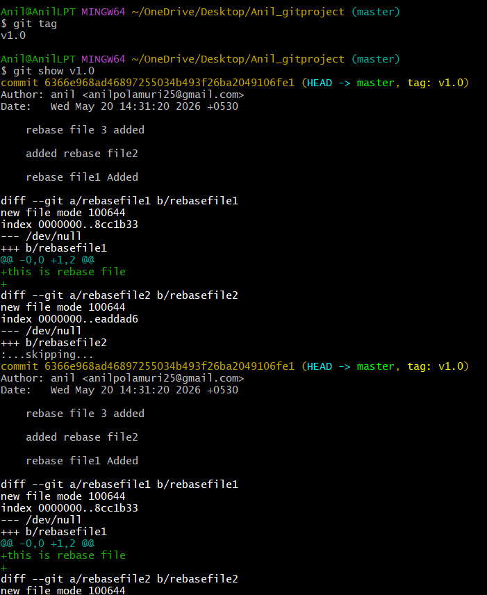

- Clone with Sparse Checkout
  - Clone only a subdirectory of a repo using sparse checkout.
Sparse checkout means:
Clone the repository, but show/download only the folder I need.
Normal clone downloads the full repo
Sparse checkout lets you work with only one folder, like

Git clone means - Normally, this downloads the repository and shows all files/folders in your working directory
git clone --no-checkout repo - downloads Git history first, but keeps the working folder empty until you choose what to checkout.We use this because we do not want all folders. We want only one folder, like frontend
Go to Desktop
(cd ~/OneDrive/Desktop)

Clone repo without checkout
(git clone --no-checkout git@github.com:anilpolamuri2825/sparse-check.git sparse-check-clone)
3. Go inside cloned repo
cd sparse-check-clone
4. Enable sparse checkout
git sparse-checkout init --cone
5. Select only one folder
For only backend folder
(git sparse-checkout set backend)
For only frontend folder:
(git sparse-checkout set frontend)
For only docs folder:
git sparse-checkout set docs
Use only one option based on what you want.
6. Checkout master branch
(git checkout master)
7. Check files
ls
You should see only the folder you selected.
ls docs
9. Check sparse checkout list
git sparse-checkout list
10. Pull latest changes later
git pull origin master
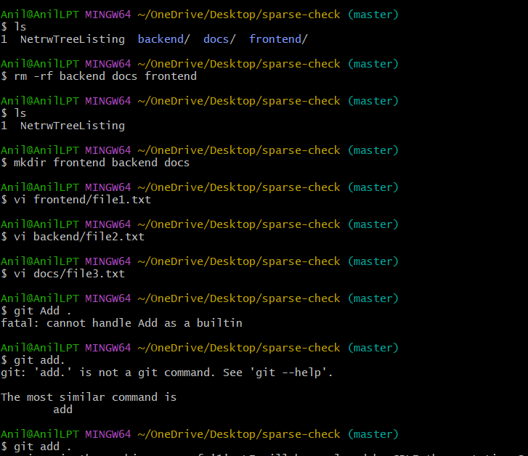
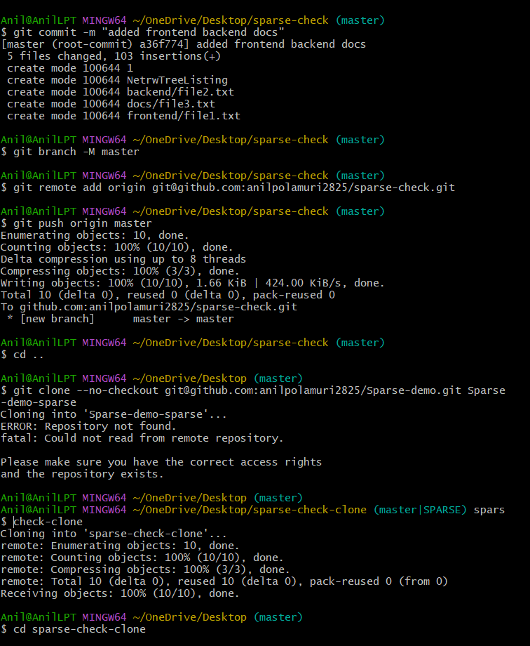
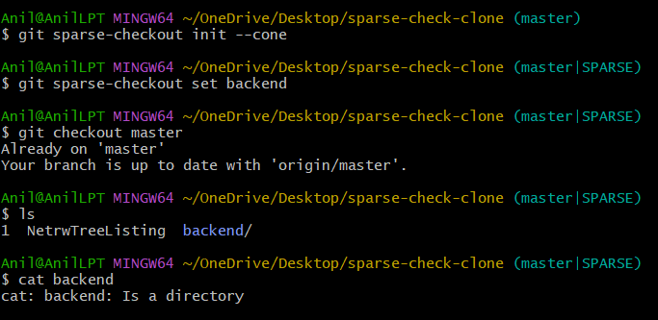

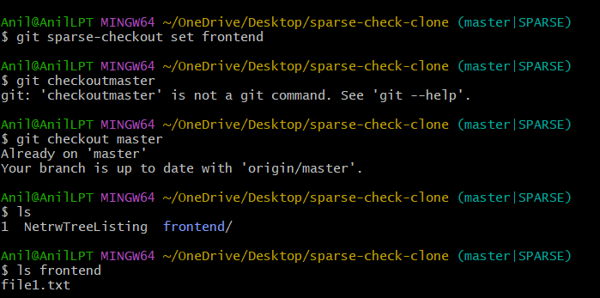

- Reset vs Revert Challenge
  - Demonstrate the difference betweengit reset --hardandgit revertin a repo.
  - git reset --hard when: The wrong commit is only local and not pushed to GitHub.

  - Use git revert when: The wrong commit is already pushed to GitHub

  - create two files and add and commit
  - Check commit history (git log --oneline)
  - Reset hard to remove latest commit (git reset --hard HEAD~1)
  - Check commit history again
  - Check files (ls)
  - Create revert test file
  - Add and commit revert file
  - Check commit ID
  - Revert the latest commit
  - Check commit history
  - Push changes
  - 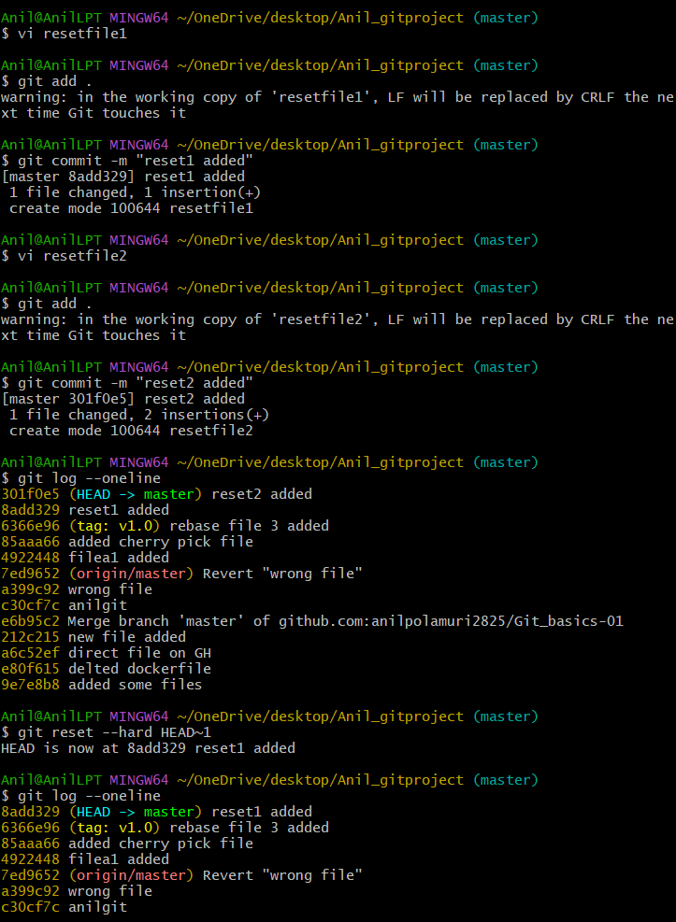
  - 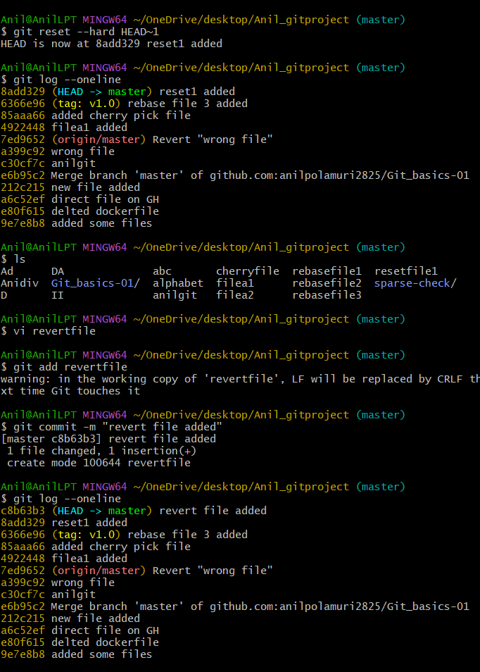
  - 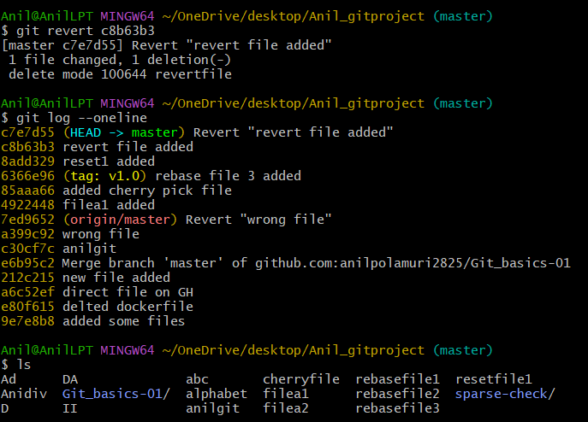

- Detached HEAD Challenge
  - Checkout a specific commit (detached HEAD state) and create a new branch from it.
  - Use detached HEAD to check old commits, but create a branch if you want to continue working from there
  - If you want to save work from that old commit, create a branch
  - Switch to master branch
  - Check commit history
  - Copy any old commit ID from the log.
  - Checkout that specific commit
  - Now Git will show a message like:
  - You are in 'detached HEAD' state.
  - (This means you are not on any branch. You are directly viewing one specific commit)
  - Check branch status
  - Create a new branch from this detached HEAD commit
  - Check branches again
  - Create a file in this new branch
  - Add and commit the file
  - 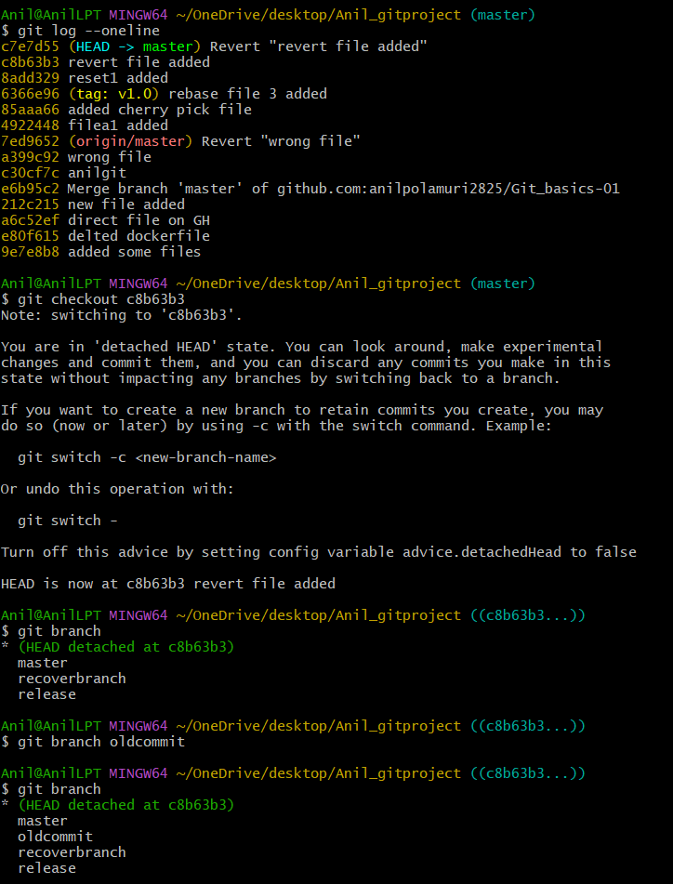
  - 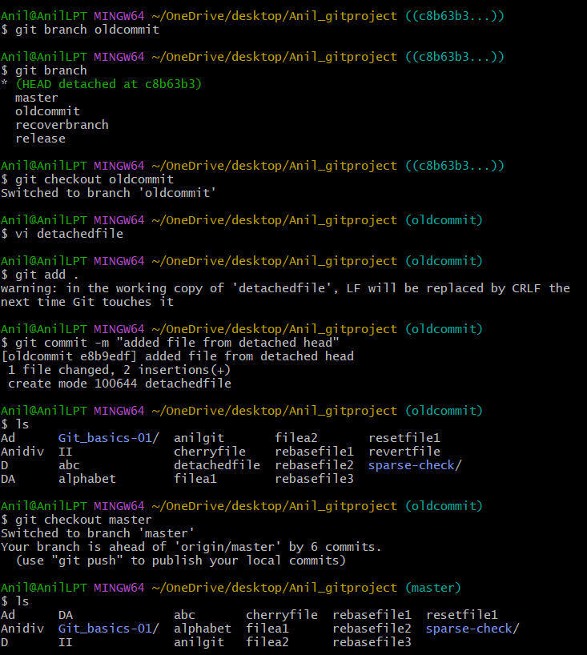

- Git Hooks Challenge
  - Configure apre-commithook to reject commits without a message format (e.g., must start withJIRA-XXX).
  - Note: For commit message validation, we use commit-msg hook, not pre-commit.
pre-commit runs before the commit message is entered.
commit-msg checks the commit message before commit is completed
  - Go to Git hooks folder - cd .git/hooks
  - Create commit-msg hook file- vi commit-msg
  - Add this script inside the file
  - Give execute permission to hook - chmod +x commit-msg
  - Go back to project root folder
  - Create a test file
  - Add the file
  - Try wrong commit message
  - Try correct commit message
  - 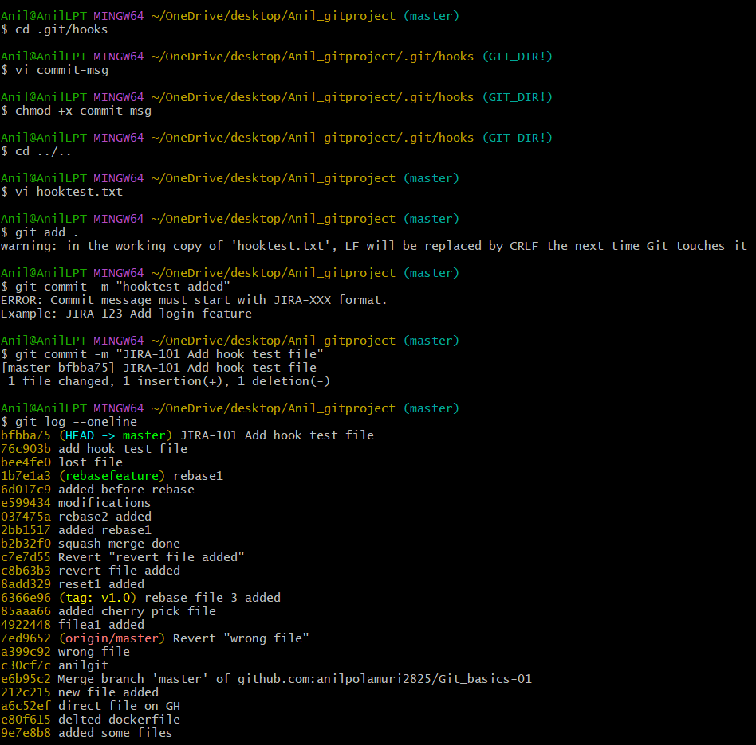

- Squash Merge vs Rebase Merge
  - Show the difference between squash merge and rebase merge with evidence
Squash merge - Take all changes from the branch and make them one commit on master
Rebase merge - Move feature branch commits on top of latest master, then merge

Create a new branch for squash merge checkout to it
create two file and commit
Check commit history shows This proves the feature branch has two separate commits
Go back to master
Squash merge the feature branch(git merge --squash squash-feature) -This brings all changes from squash-feature into master, but it does not bring the two commit histories
(Two commits from squash-feature become staged changes on master)
Create one final squash commit -Now master gets only one commit for both files
Check evidence for squash merge (git log --oneline --graph --all)
explanation- On master, you will see only -Squash merge squashfeature changes (So the two commits from the feature branch were combined into one commit on master.)

Rebase Merge Demo

Create another branch from master
create 2 rebase files and commit
Go back to master
Create one new commit on master
Commit master change - (Now master has moved ahead.)
Go back to rebasefeature
Rebase feature branch on latest master - (git rebase master
This moves the rebase-feature commits on top of the latest master) - (Git takes your rebase-feature commits and places them after the latest master commit)
Go back to master
Merge rebasefeature into master - Master simply moves forward to include the rebasefeature commits
Check evidence for rebase merge - In rebase merge, the two commits are still visible separately

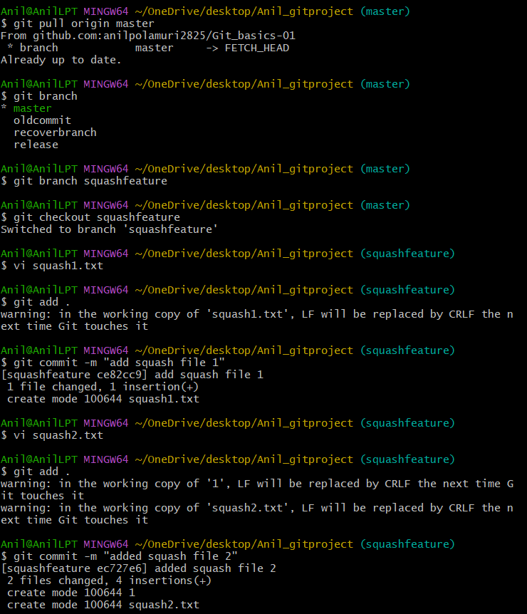
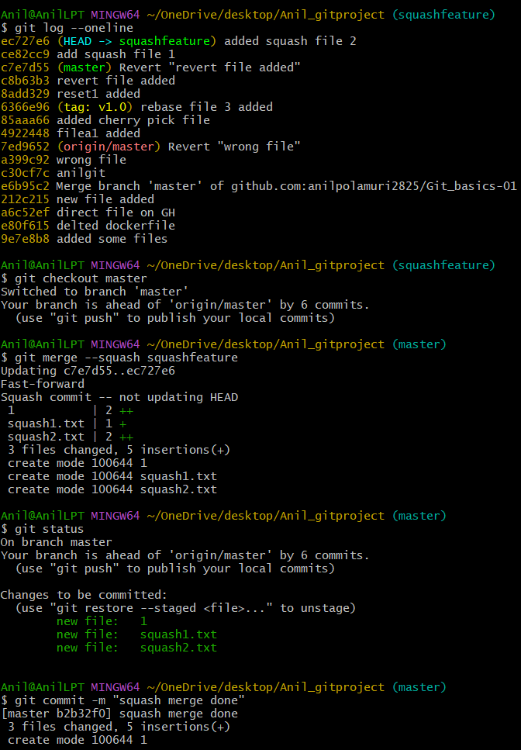
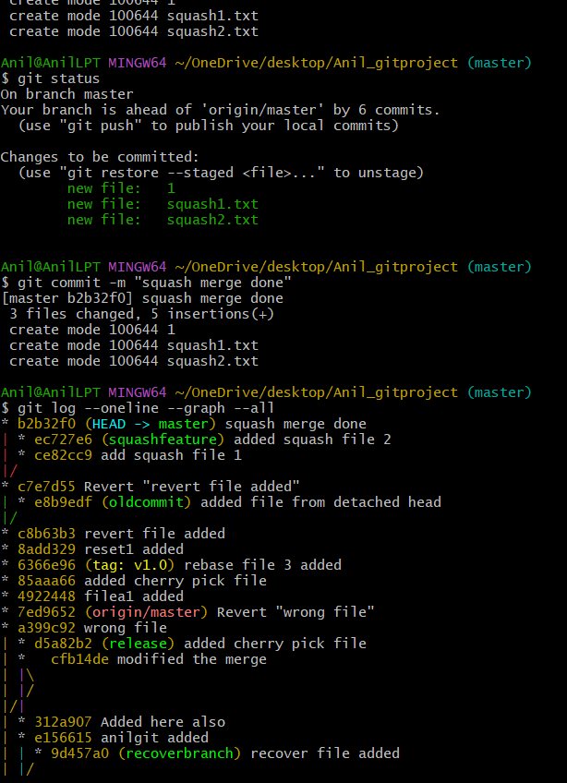
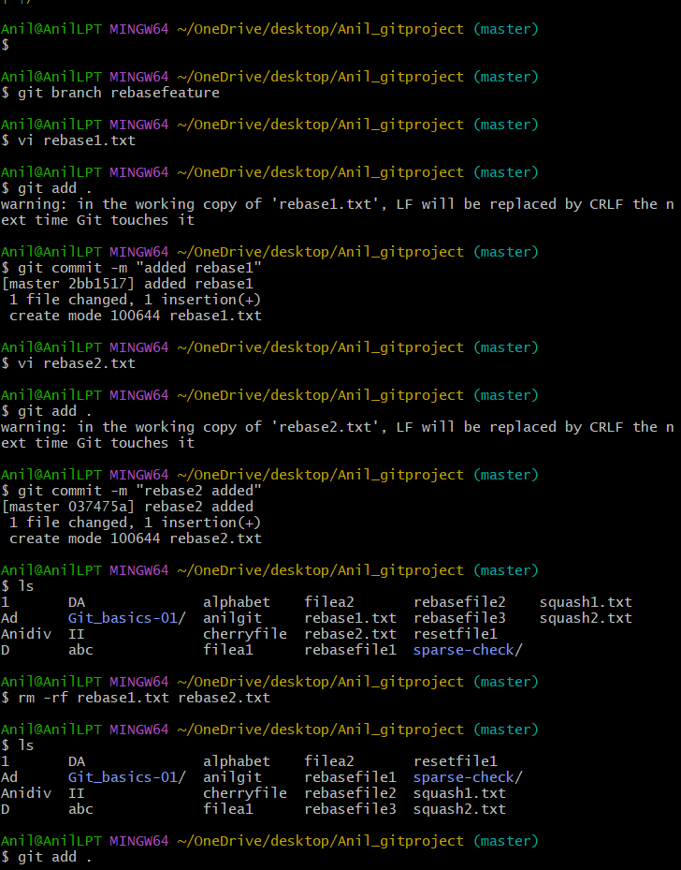
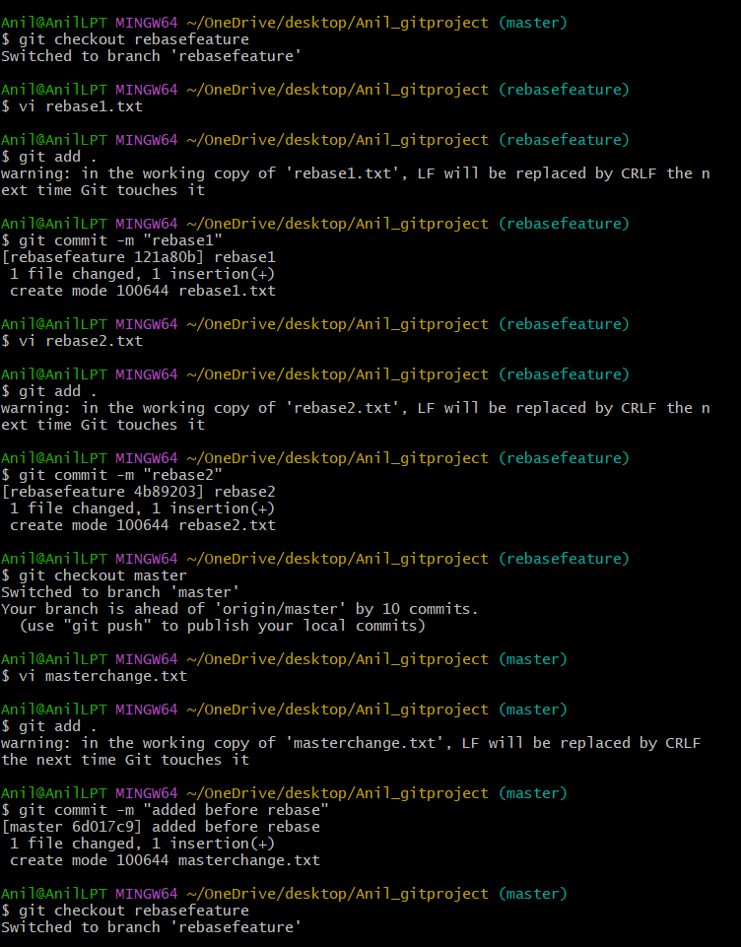
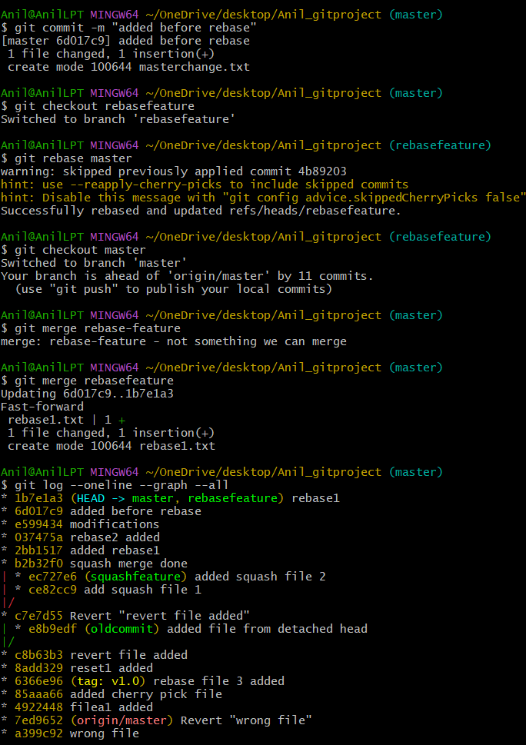
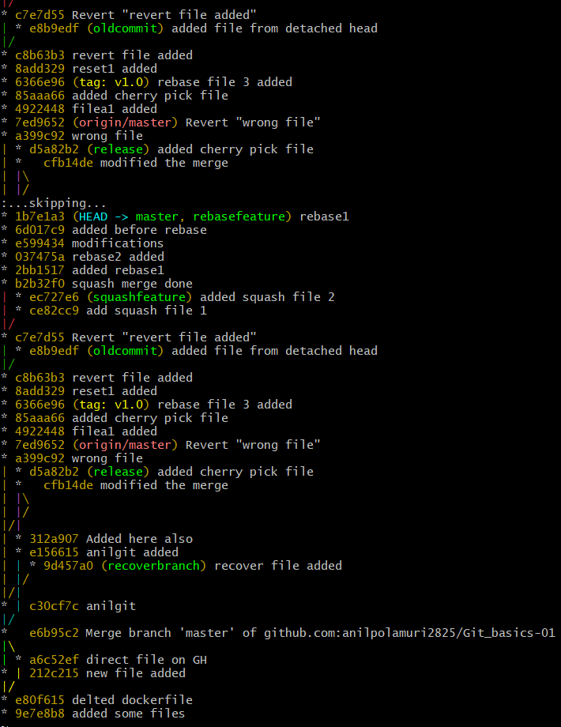

- Fork & Pull Request Workflow
  - Fork a repo, make a change, and submit a pull request to the original repo.
Open another person’s GitHub repository
Click Fork
Open your forked repository
After forking, GitHub will take you to your copy
Copy SSH URL from your fork
Open Git Bash and go to Desktop
Clone your fork
Go inside the project folder
Create a new branch
Make a change in a file
Add the file and commit
Push your branch to your fork
Open your fork on GitHub
Check PR direction
Click Create pull request

  - 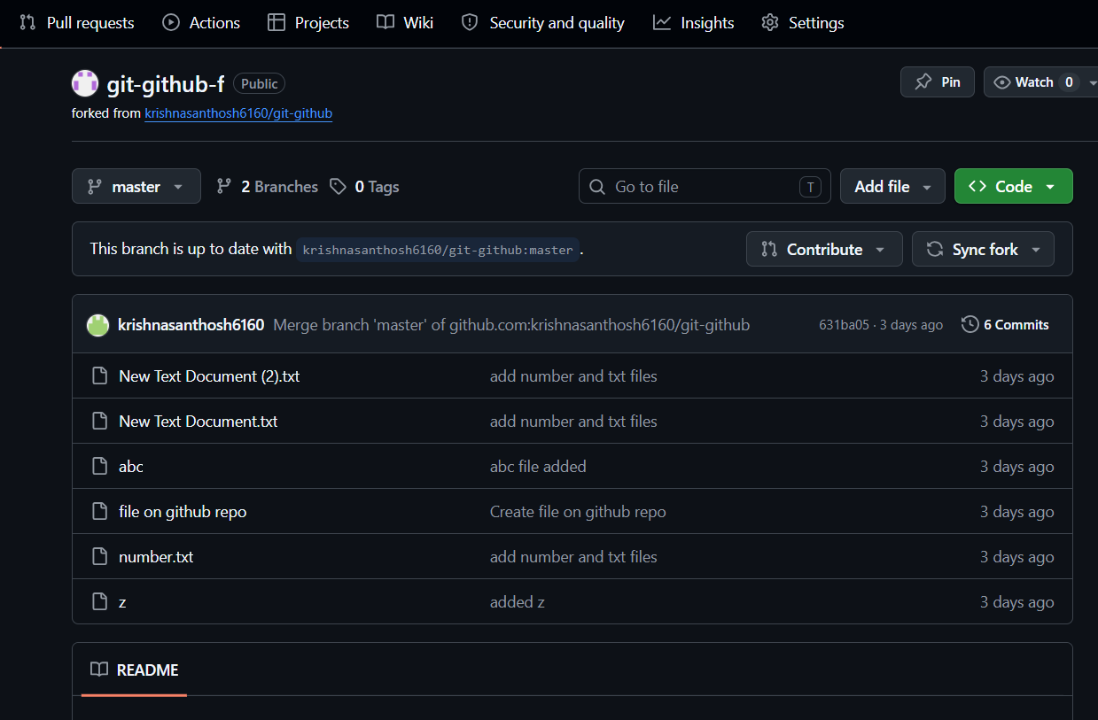
  - 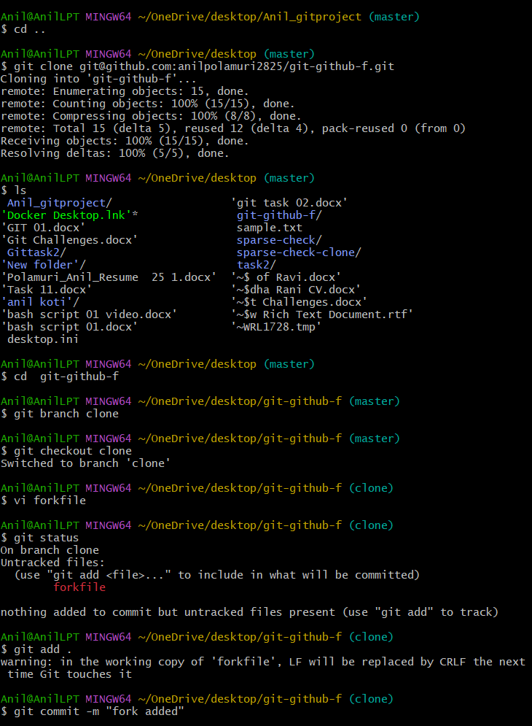
  - 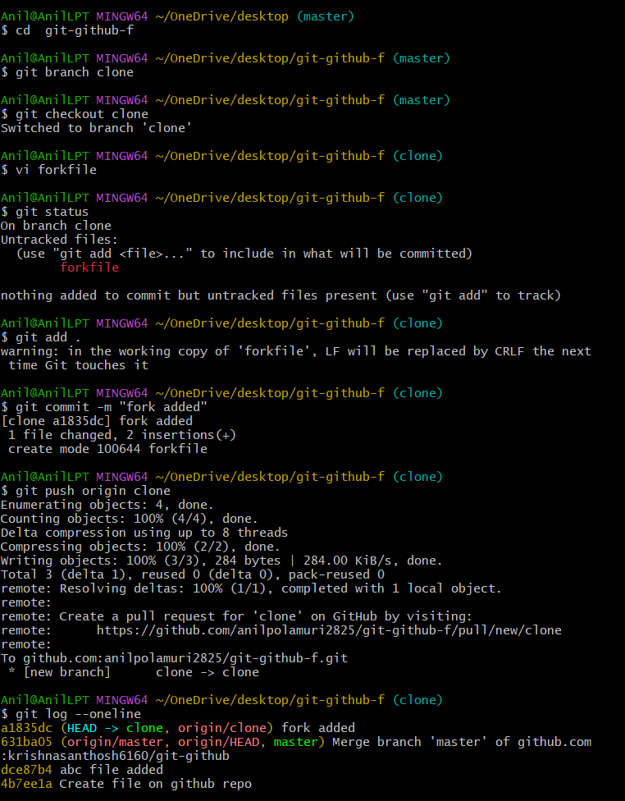

- Recover Lost Commit
  - Commit something, reset hard, and then recover it usinggit reflog.
  - Create a new file
  - Add content inside the file
  - Commit the file
  - Check commit history
  - Reset hard to remove the latest commit: git reset --hard HEAD~1
  - Check log again - you wont find file
  - Check reflog
  - Find the lost commit line
  - Recover the lost commit - git reset --hard commitid
  - Verify commit is recovered
  - 
   